Lex specification

Source code: <https://github.com/davidalexandru1370/LabLFTC/tree/lab9>

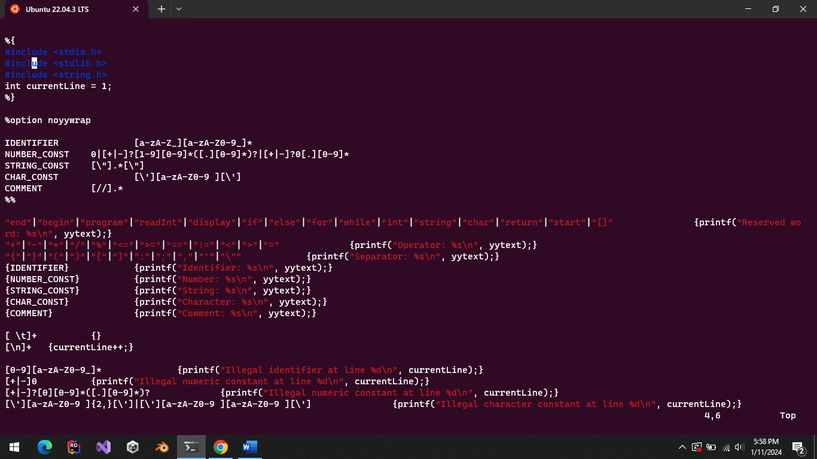

Source code



To compile this code we are using the following command in unix terminal:

flex scanner.lxi

this command will generate a lex.yy.c file which is the parser for our regexes:



Compiling the lex.yy.c file with the command gcc -Wall -g -o a.exe lex.yy.c will give us an executable called a.exe which is the parser for our defined regexes to which we can pass the p1..p3 program files.

The output of parsing p1 will be the following:

